Math 10

Lesson 5-1 Answers

**Lesson Questions**

**Question 1**

–4

2

4

–4

–2

2

4

–2

*x*

*y*





Point of intersection is (3, –1)



Check

 

The solution is *x* = 3 and *y* = –1

–4

2

4

–4

–2

2

4

–2

*x*

*y*

**Question 2**



They meet after travelling for approximately 0.9 h and at approximately 2.2 km from Tyrell’s cabin.

**Question 3**

40

40

80

20

20

60

80

60

*r*

*s*

a) Let *r* be the received messages and *s* be sent messages. From the first sentence:



From the second sentence:





b) According to the graph he sent 35 and received 25



**Question 4**

80

80

160

40

40

120

160

120

*x*

*y*

a) Let *x* be the time for the opening act and *y* the main act. From the 1st sentence:





From the 2nd sentence:



b) The solution is (45, 87). The opening act was 45 minutes long and the main act was 87 minutes long.



**Assignment**

1. Determine the solution of each linear system.

a) (–4, 2)

b) (2, 3)

c) (1, –3)

d) (–2, –1)

2. Solve each linear system.

a) *x* = 4, *y* = 3 b) *x* = 2, *y* = 3

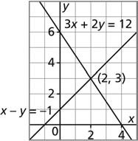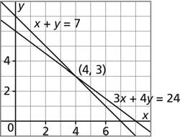

c) *x* = 6, *y* = –5 d) *x* = –3, *y* = 1

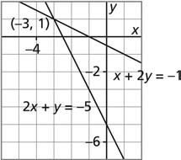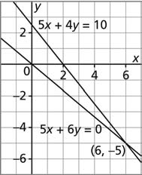

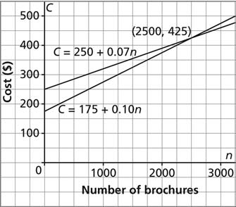3.

b) i) 2500 brochures

ii) It is cheaper to use Company A when fewer than 2500 brochures are printed.

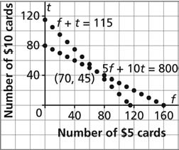4. Variables may differ. *f* + *t* = 115 and 5*f* + 10*t* = 800

Seventy $5 gift cards and forty-five $10 gift cards; exact

5.

Variables may differ.

4.8*s* + 8.0*a* = 152 and *s* – *a* = 13

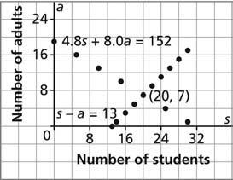

7 adults and 20 students; exact

6. First, graphing takes a long time to do, even on a graphing calculator. Second, neat looking graphs are difficult to construct. Third, the answers are often just approximate. Finding the exact answer is difficult.

7. Variables may differ.

a)  and 

8. a) iii; *x* dollars represents the cost of a jacket and *y* dollars represents the cost of a sweater.

b) i; *x* represents the length in feet and *y* represents the width in feet.

c) ii; *x* represents the number of chapatti breads sold and *y* represents the number of naan breads sold.

9. Variables may differ.

a) 2*s* + 2*l* = 20 and *s* + 3*l* = 22

10. Variables may differ.

a) 2*l* + *s* = 24 and *l* – *s* = 6